

22 November 2018
Operational Update
Automation and Capacity Project – Update

Our project to transform Fergusson Terminal which will provide future capacity is well underway and visitors to the port will have seen a lot of activity and changes including civil works, construction workers and sections of tarmac undergoing renewal. What has been happening recently:

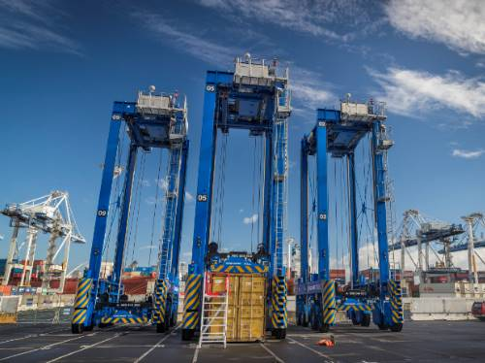
A-Strads
Visitors will have seen the new blue “A Strads” now assembled on the north end of the terminal, undergoing a comprehensive range of testing in readiness for Go-Live next year.

Road Exchange
The work to upgrade the truck lanes has been completed and the next stage is installing the gates and fences required to keep truck drivers and A Strads separated.

Pre-gate Kiosk Screens
These have been updated. Drivers now need to complete some additional steps at the kiosk. This means that when automation goes live, the drivers will already be familiar with the new system.

Reefer Gantries
The large shiny frames of the new reefer gantries at the southern end of the Fergusson terminal are now complete and sign-off for the reefer operation is expected before the end of this year. In the meantime, we have been able to use the area as valuable stacking space for dry containers.

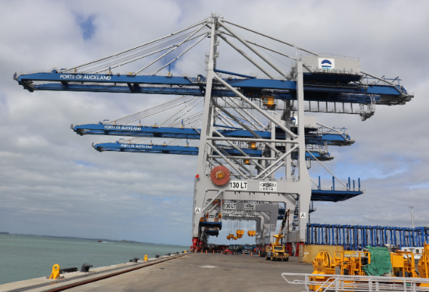
New Container Cranes
There was a lot of media interest and celebration with the arrival of our three new container cranes on the specialised delivery vessel Zhen Hua 25. It was a great sight to see them sail into the harbour in the early morning. These cranes, which have quad-lift capacity (they can lift four containers at once), are now in place on Fergusson North Berth and will be commissioned early 2019, after a range of testing required to integrate them into our current systems.

Hatch Platforms have now been installed on all container cranes – these allow the ship’s hatch covers to be stored above the ground, freeing up space around the cranes for container handling.

Lash Platforms In a first for New Zealand, we’re installing lash platforms on all our cranes and our new cranes have them already fitted. This will make stevedores’ job safer, as they can work above ground away from moving straddles.

Rail OCR (Optical Character Recognition)
A frame, fitted with multiple cameras, has been placed over the rail line to capture images and recognise container numbers arriving and leaving by rail. This system provides a high degree of accuracy and enables rail planners to quickly check on any “exceptions”.

Supply Chain Challenges
There are a range of challenges being experienced throughout the supply chain. We are automating Fergusson Terminal to increase capacity and productivity, whilst at the same time experiencing unprecedented volume demand. It is a bit like having heart surgery while playing rugby!

While we’re carrying out the automation work our terminal capacity is actually reduced, putting pressure on our operations especially during peak import season.

We are undertaking this transformation to ensure we are ready to accommodate Auckland’s rapid growth in freight demand. We’ll be able to handle more containers on the same land, but it also means some changes in the way cargo owners and trucking companies interact with the port.

Greater planning and different ways of operating are needed throughout the freight supply chain. The port operates 24/7 and yet the wider supply chain largely works 24/5 at best, and often 9 to 5 Monday to Friday.

Extended operational hours are needed at distribution centres, empty depots and importers’ and exporters’ premises to maximise the capacity of the whole supply chain. It is much the same as an internet connection – you’re currently on dial-up and want to upgrade to fibre, but you only get the best speed if you’ve got fibre end-to-end.

We have been engaging with importers, exporters, trucking companies and freight forwarders to discuss the changes and welcome you to make contact to discuss any issues you may have.

Further Progress
Our automation go-live date is late 2019. There are a number of civil, operational, engineering and I.T. projects being undertaken, some of which need to be completed in a specific order and others are more flexible. This means that we are continually adjusting the timing of work. We will keep you updated on progress and changes.
Please contact us if you have any questions or would like to discuss any ideas or concerns, at any stage.

For more information contact  Customer Service  P: +64 9 348 5100 Ext. 1  E: customerservice@poal.co.nz | For VBS queries contact  Transport Co-ordinators  P: +64 9 348 5100 Ext.2  E: driversassist@poal.co.nz

Ports of Auckland have joined the Climate Leaders Coalition - a collection of business leaders who have each committed to act on climate change.
Ports of Auckland is the first port in the world to make this commitment and the first port in New Zealand to be CEMARS® certified. Joining the coalition contributes to the ports promise to become zero emissions by 2040.
More information on the Climate Leaders Coalition can be found here. Read the CEO Climate Change Statement here.

